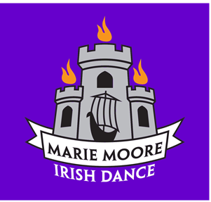

Marie Moore School of Irish Dance
302B Park Avenue
Scotch Plains, NJ 07076
Tel: (908) 322 9099
Email: mariemooreirishdance28@yahoo.com
Website: Mariemooreirishdance.com

Marie Moore, ADCRG, BG Frank Cunniffe, ADCRG Jen Dawson, TCRG

Photograph and Video Release Form

I hereby grant the Marie Moore School of Irish Dance, LLC permission to take photographs, video recordings of myself and my child/children in connection with Irish Dance.

I authorize the release of these photos/videos of me/my child to be used with or without my/my child’s name and for any lawful purpose including for example such purposes as publicity, advertising and Web Content. These photos may be taken in class, at Feis’ (competition), recitals, social occasions etc.

I will be consulted about the use of the photographs or video recordings for any purpose other than those listed above.

There is no time limit on the validity of this release nor is there any geographic limitations on where these photos/videos may be distributed.

Bu signing this Form, I acknowledge that I have completed read and fully understand the above release and agree to be bound thereby.

Signature of Full Name______________________________________________________________

Printed Full Name_________________________________________________

Address:____________________________________________________________

City_____________________________________________________ Postal Code_____________________________________

Phone:_______________________________________________________

Email Address (please print clearly) ______________________________________________________________________

Date:_________________________________________

